\

0**** Please do not edit this document. This includes any cut/copy/paste. Only the PMO does the edits.

**TO LOG ON TO THE AWS VDI**

 M

Step 1 : Open the link [L20a](https://clients.amazonworkspaces.com/).

Step 2 : Choose the appropriate download icon as per your system OS and download the .msi file.

PPMachine generated alternative text:
WorkSpaces Connection Status Check Terms 
Amazon Workspaces plays nice with everyone. Access your personal Windows environment on Android iOS, Fire, Mac. PC Chromebook, and 
fire Tablet 
Web 
En 
c 2021, 
Web Access Login 
Linux devices. 
WATCH THE VIDEO 
Co i -"Ole Privuy Site 
Get the latest client 
Older version 2-5. I I 

Step 3 : Run the downloaded .msi file.

Machine generated alternative text:
Amazon WorkSpaces plays nice with everyone. Access your personal Windows environment on Android, iOS, Fire, Mac, PC, Chromebook, 
Linux devices 
WATCH THE VIDEO 
and 
x 
Open File - Security Warning 
Do you want to run this file? 
Name: 
Publisher: 
Type: 
From: 
...a51-8ee0-45132622828e\Amazon+WorkSpaces.msi 
Amazon.com Services LLC 
Windows Installer Package 
C:\Users\Harihk\AppData\Local\Temp\MicrosoftEdg... 
Run 
Cancel 
While files from the Internet can be useful, this file type can 
potentially harm your computer. Only run software from publishers 
you trust. What's the risk? 

Step 4 : Enter your Deloitte credentials to allow running.

Machine generated alternative text:
Virtual desktops have never been easier... or fas 
x 
Keeping Deloitte Secure 
Amazon WorkSpaces plays nice with everyone. Access your personal Windows environ 
Linux devices 
Deloitte. 
Credentials Required 
WATCH THE VIDEO 
This action requires administrative privilege to run. To continue, enter your password, 
then dick OK. Unexpected elevation prompts should be canceled and reported to your 
local support desk. 
LIS - (Default) Any I-IAC Prompt 
C: VserslHarihk\AppDatalÅ... +WorkSpaces. ms 
Program Name 
Program Publisher 
Program paål 
US\harihk 
Password 
Amazon +WorkSpaces. 
Amazon.com Services LLC 

Step 5 : Follow the Amazon WorkSpaces Setup as shown below, step-by-step :

gMachine generated alternative text:
Virtual desktops have never been easier... or faster. 
Amazon WorkSpaces Setup 
Amazon WorkSpaces plays nice with everyone. Access your personal Windows envir 
Linux devices 
WATCH THE VIDEO 
x 
Welcome to the Amazon WorkSpaces 
Setup Wizard 
The Setup Wizard will install Amazon WorkSpaces on your 
computer. Click Next to continue or Cancel to exit the Setup 
Wizard. 
Back 
Next 
Cancel 

Machine generated alternative text:
Linux devices 
WATCH THE VIDEO 
Amazon WorkSpaces Setup 
Installation Scope 
Choose the installation scope and folder 
@Install just for you (harihk) 
Amazon WorkSpaces will be installed in a per-user folder and be available just for your 
user account. You do not need local Administrator privileges. 
O 
Install for all users of this machine 
Amazon WorkSpaces will be installed in a per-machine folder by default and be 
available for all users. You can change the default installation folder. You must have 
x 
local Administrator privileges. 
Back 
Next 
Cancel 

Machine generated alternative text:
Linux devices 
WATCH THE VIDEO 
Amazon WorkSpaces Setup 
Ready to install Amazon WorkSpaces 
Click Install to begin the installation. Click Back to review or change any of your installation 
x 
settings. Click Cancel to exit the wizard. 
Back 
Install 
Cancel 

Machine generated alternative text:
v 11 LUdL I lave 'level ween ect>lel... ul Id3te1. 
Amazon WorkSpaces plays nice with everyone. Access your personal Windows environment n Android iOS Fire Mac P 
Chromeboo 
an 
Linux devices 
WATCH THE VIDEO 
Amazon WorkSpaces Setup 
Installing Amazon WorkSpaces 
Please wait while the Setup Wizard installs Amazon WorkSpaces. 
x 
Status: 
Updating component registration 
Back 
Next 
Cancel 

Step 6 : Once the installation is complete, open Amazon WorkSpaces application.

Machine generated alternative text:
All Apps 
Best match 
Documents 
Web 
More 
Virt 
Amazo 
Linux d 
aws worr 
Amazon WorkSpaces 
App 
Search work and web 
p workspaces 
- See work and web results 
p workspaces jnj 
p workspaces kde 
p workspaces aws 
p workspaces 32 bit 
p workspaces windows 
P workspaces download 
p workspaces 
Amazon WorkSpaces 
App 
Open 
Run as administrator 
Open file location 
Pin to Start 
Pin to taskbar 
Uninstall 
6 
Web Access 
63 
Web Access Login R 
@ 200B- 2021 , Amazon Web Servicæ, Inc. or its affiliates. All rights reserved. 
9:10 AM 
2/2/2021 

Step 7 : Enter one of the following activation codes: wssin+5FW34X OR SLiad+B9NXHC OR

wssin+NLH64U. If one code doesn’t work, try the other code. In case both are not working, inform the PMO team.

Machine generated alternative text:
x 
WorkSpaces Connection Status Check Terms 
Amazon WorkSpaces 
Amazon WorkSpaces Settings 
Web Access Login R 
Support 
Virtual desktops have never been ea 
Amazon WorkSpaces plays nice with everyone. Access your personal 
Linux devices 
WATCH THE VIDEO 
iPAd 
amazon 
WorkSpaces 
To get started, enter the registration code provided to 
you by your administrator. 
Enter your registration code 
Maroc, X 
Register 
Windows 
Tahlpt 
Wpb Arrpsq 

Step 8 : Enter your credentials and log into WorkSpaces.

Machine generated alternative text:
Delete Archive 
R Junk v 
Delete 
Reply 
Reply Forward 
Respond 
Amazon WorkSpaces 
Amazon WorkSpaces Settings Support 
amazon 
WorkSpaces 
Please log in with your westernunion-fsi 
9 
ng 
Read 
Aloud 
Speech 
Reply All 
Zoom 
Zoom 
Repon 
Phishing 
Deloitte 
[EXT] Activating Your Western Un 
no-reply.ipass@westernunion.com 
To O HariHaraSubramaniyan.K@wu.com; e 
(C) Click here to download pictures. To help protect your priva 
e. You will be prompted to complet 
f. Your Okta account is now set up a 
g. Your PC will prompt you to enter 
Western Union requires multi-factor authen 
gaining access to company assets. Okta Veri 
Below are your Western Union credentials a 
Your company email is 
Your WU Employee ID is 
Your temporary HQINTLI password is: 
Okta sign in page is 
If you need assistance, please reach out to y 
-9 Forward 
Sat 1/30/2021 11:08 AM 
76057233 
credentials 
Sign In 
Access your desktop anywhere, anytime, 
from any device 
rify the identity of a user prior to 
Keep me logged in 
Change Registration Code 

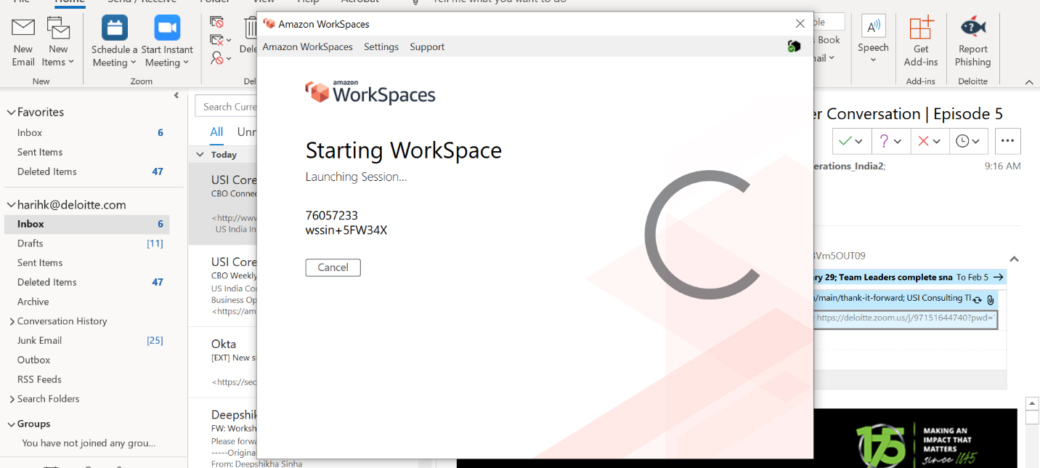

Step 9 : Enter your HQINTL1 password (received in a mail for Okta access) and log into the VDI

Machine generated alternative text:
Amazon WorkSpaces 
Amazon WorkSpaces View Settings Support 
Hari Hara Subramaniyan K 
assword 

**TO AVAIL ACCESS FOR APPLICATIONS AND TOOLS**

Step 10 : Open westernunion.okta.com using browser (edge preferred) on AWS Workspace. Enter your credentials, if required.

Machine generated alternative text:
Amazon WorkSpaces 
Amazon WorkSpaces View Settings Support 
O Western Union - Sign In 
Sign In 
WU Employee ID or Email 
76057233 
HQINTLI Password 
Remember me 
Sign In 
Need help signing in? 
P 
e 
1&49AM 
2/2/2021 

Step 11 : Open iPASS.

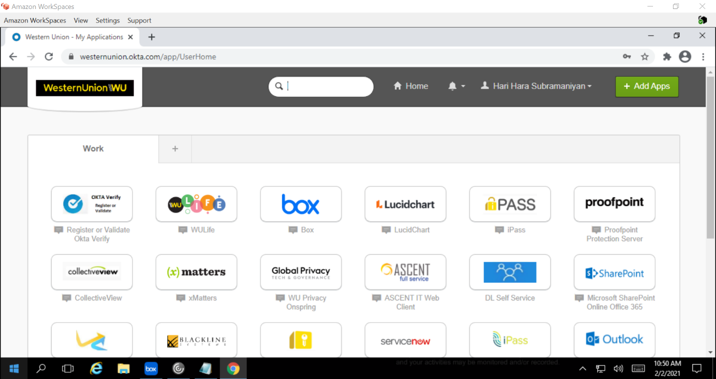

Step 12 : Choose Manage My Access.

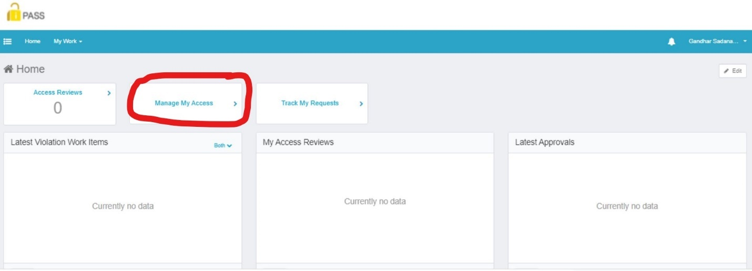

Step 13 : Find the tool required by using the search-box

. At a minimum, you should request access to Jira, Pulse Secure (if you are going to avail any WU equipment) and Outlook Exchange.

**JIRA**:

* Click on Filters button and select ‘WU Jira’ as the Entitlement Application
* Select your ID for ‘WU Jira Users’.
* Click on Next.
* Right before the 'Details' button, you should see message icons for both requests. Click on those icons to save comments providing the business justification for this access request.
* Save the comments and click on the Submit button.

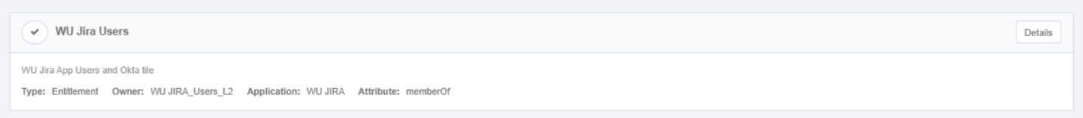

**Confluence**:

* Click on Filters button and select 'WU Confluence' as the Entitlement Application
* Look in the options for 'WU Confluence Users'
* Then select the option where sub heading is 'WU Confluence App Users and Okta tile'(as shown in below snipshot)
* When prompted by iPass to select the account you need the access for, select your ID and click on Apply.

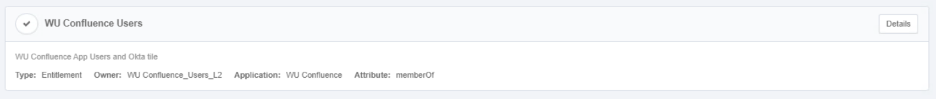

**Pulse secure**:

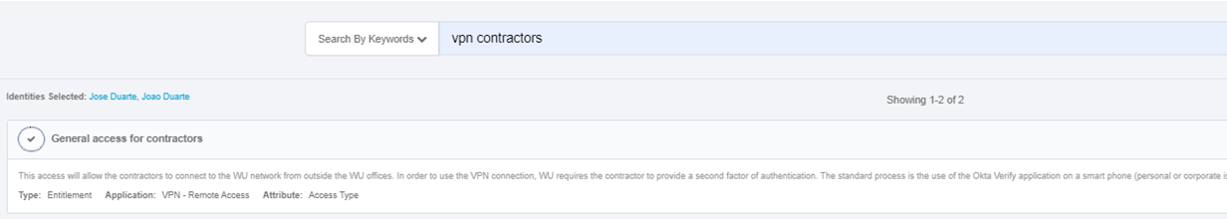

**Outlook & Teams**:

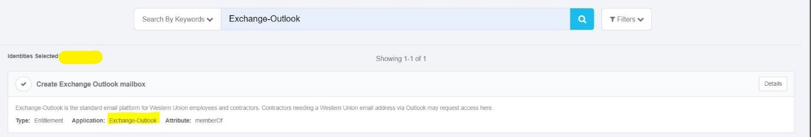

**Box**:

Box tile in Okta portal should appear by default. If not visible, Raise Box access by following below path:

* Ipass> manage my access> search "end user to box" and raise it

Once box tile is visible in Okta portal, reach out to PMO spoc to include you in Western Union Project Box folder.

Step 14 : Choose the application from the search result.

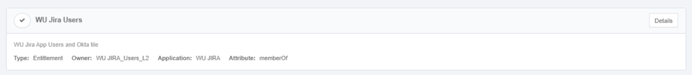

Step 15 : Submit the request for access after choosing all required applications.

Step 16 : Choose Track My Requests to see your submitted access requests.

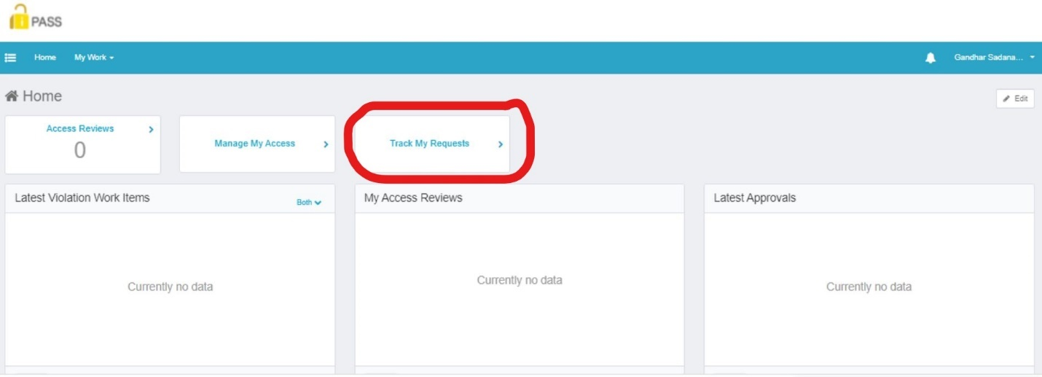

**TO SET-UP PASSWORD RECOVERY QUESTIONS**

Step 17: Visit <https://westernunion.okta.com/enduser/settings> and choose Forgotten Password Question

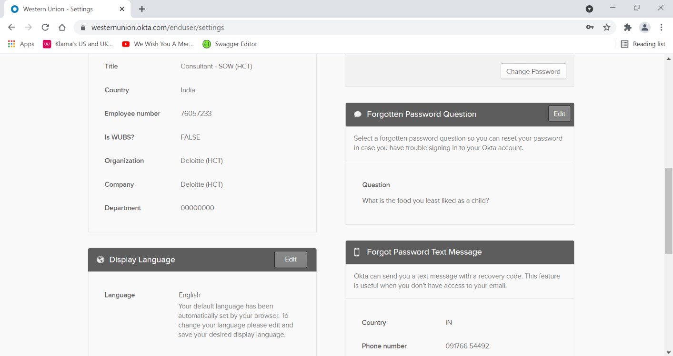

Step 18: Choose a suitable recovery question and enter appropriate answer that you can remember. Save and close.

